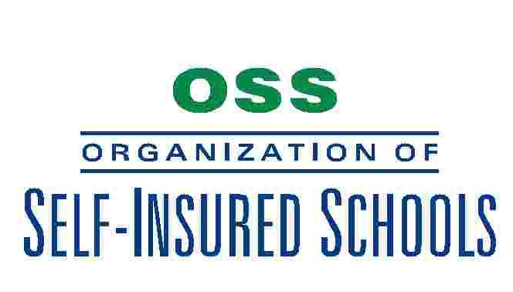
Executive Committee Meeting
9:00 a.m. Tuesday, May 17, 2011

Southwest Education Support Center
16644 S. Elm
Caruthers, CA 63609

A G E N D A

- CALL TO ORDER AND ROLL CALL

- APPROVAL OF AGENDA

- PUBLIC HEARING SESSION

- CONSENT AGENDA
  - Approval of Minutes of the April 21, 2011 Meeting as Mailed

- BROKER'S REPORT

- ACTION ITEMS
  - Consider Recommendation to the Board of the Revised Loss Fund Rate
  - Consider Recommendation to the Board of the NorCal Rates

- BOARD MEMBER REPORT

- CLOSED SESSION

- OTHER ACTION
- NEXT MEETING – Thursday July 21, 2011 – Rodolfo’s, Selma

- ADJOURNMENT

