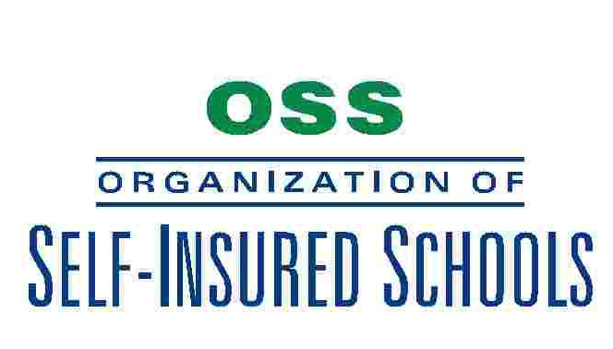

Annual Board Meeting
10:00 a.m. Tuesday, May 17, 2011

Southwest Education Support Center
16644 S. Elm
Caruthers, CA 63609

A G E N D A

- CALL TO ORDER AND ROLL CALL

- APPROVAL OF AGENDA

- PUBLIC HEARING SESSION

- CONSENT AGENDA

  - Approval of Minutes of May 18, 2010 Meeting as Mailed

- BROKER'S REPORT

- ADMINISTRATOR'S REPORT

7. LOSS CONTROL REPORT

- ACTION ITEMS
  - Consider Approval of Loss Fund Rates
  - Consider Approval of NorCal ReLiEF Rates
  - Consider Approval of O.S.S. Rebate Payment
  - Consider Approval of NorCal ReLiEF Rebate Payment
  - Consider Budget for 11/12 Year
  - Consider At Large Membership on the Executive Committee
- BOARD MEMBER REPORT

10. CLOSED SESSION

11. OTHER ACTION

12. NEXT MEETING – Tuesday, May 15, 2012 – Southwest Education Support Center, Caruthers

13. ADJOURNMENT

